Department of
Artificial Intelligence and Machine Learning
B.Tech III Semester Academic Year 2026-2027
Data Analysis Essentials(2501AI06)
Corner Stone Project Documentation


ADITYA UNIVERSITY
Surampalem, Kakinada District Andhra Pradesh-533437



School of Computing

Department of Artificial Intelligence and Machine Learning

DATA ANALYSIS ESSENTIALS
CERTIFICATE

This is to certify that the Cornerstone project work entitled “STUDENT PERFORMANCE DATA ANALYSIS SYSTEM” is submitted by

P. Surya Vamsi 25B11AI905
Ram Charan Teja 25B11AI195
M.Vishnu 25B11AI650
Krishna Raju 25B11AIB34

in partial fulfilment of the requirements for the award of the B.Tech. degree in Artificial intelligence and machine learning the academic year 2026-2027.

Project Guide Head of the Department
A Sophia Dr. K. Naga Bhargavi, Ph.D,
, Assistant Professor, Associate Professor & HOD
Department of AIML Department of AIML

DECLARATION

We hereby declare that the project entitled “STUDENT PERFORMANCE DATA ANALYSIS SYSTEM” is our original work and is submitted to ADITYA UNIVERSITY, Surampalem, in partial fulfillment of the requirements for the award of the B.Tech. degree in Artificial Intelligence and Machine learning-
We further declare that this project work has not been submitted, either in full or in part, for the award of any degree or diploma in this or any other institution. We also confirm that this work has been carried out with academic honesty and complies with the Institutional Academic Integrity and AI Usage Policy.
Place:
Surampalem
Date:
25-09-2026
BY:
P. Surya Vamsi 25B11AI905
Ram Charan Teja 25B11AI195
M.Vishnu 25B11AI650
Krishna Raju 25B11AIB34

ACKNOWLEDGEMENT

ACKNOWLEDGEMENT
It is with immense pleasure that we express our sincere gratitude to our Cornerstone Project Guide, Alamanda Sophia, Assistant Professor, who has guided us throughout the project. Her valuable support, encouragement, and guidance have greatly contributed to the successful completion of this work.
We would like to thank our Deputy Heads of the Department, Dr. Bollu Manikyala Rao, Associate Professor and Dr. Dasari Veeraswamy, Assistant Professor, Dr. Suneetha Racharla, Assistant Professor Department of AIML, for their support and valuable suggestions.
Our deepest thanks to our Head of the Department, Dr. Kovvuri N Bhargavi, Associate Professor & HOD, for her inspiration and for providing all the necessary facilities and resources required for this project.
We also extend our sincere thanks to Dr. M.V. Rajesh, Associate Dean, School of Computing, for his encouragement and support during our project.
We would like to express our sincere gratitude to Dr. G. Suresh, Registrar; Dr. A. Ramesh, Pro Vice-Chancellor (Engineering & Sciences); Dr. S. Rama Sree, Pro Vice-Chancellor (Academics); Dr. M.B. Srinivas, Vice-Chancellor; and Dr. M. Sreenivasa Reddy, Deputy Pro Chancellor and Management, Aditya University, for providing excellent infrastructure and state-of-the-art laboratories.
Finally, we would like to thank the faculty members, lab technicians, non-teaching staff, and our friends who have directly or indirectly supported us in completing this Cornerstone project successfully.

ABSTRACT
The Student Performance Data Analysis System is a Python-based data analysis project developed to analyses and understand student academic performance. The system uses a student performance dataset and performs dataset loading, data exploration, data cleaning, preprocessing, performance analysis, visualization, and report generation.
The project uses Pandas, NumPy, and Matplotlib in Google Colab for data processing and analysis. The system checks missing values, duplicate records, incorrect data, and outliers. It calculates student averages, generates grades, sorts and filters student records, identifies top-performing students, and analyses department-wise performance.
Different visualizations such as bar graphs, pie charts, and performance comparison graphs are used to understand the data more effectively. Finally, the system generates a cleaned dataset and analysis report.
This project demonstrates how Python-based data analysis can reduce manual effort and provide meaningful insights into student performance

Table of contents

S.No. | Contents | Pages
1 | Title Page | i
2 | Certificate | ii
3 | Declaration | iii
4 | Acknowledgement | iv
5 | Abstract | v
6 | Table of Contents | vi
7 | List of Figures | vii
8 | List of Tables | viii
Chapter 1 | Introduction | 09-11
1.1 | Introduction to the Project | 09
1.2 | Problem Statement | 09
1.3 | Objectives of the Project | 10
1.4 | Scope of the Project | 11
Chapter 2 | Dataset Description and Understanding | 12-14
2.1 | Dataset Source | 12
2.2 | Dataset Description | 12
2.3 | Features / Attributes | 13
2.4 | Target Variable, if applicable | 13
2.5 | Dataset Statistics / Initial Exploration | 14
Chapter 3 | Data Preprocessing | 15-18
3.1 | Data Collection / Loading | 15
3.2 | Handling Missing Values | 15
3.3 | Handling Duplicate / Inconsistent Data | 16
3.4 | Feature Scaling | 16
3.5 | Standardization | 17
3.6 | Label Encoding | 17
3.7 | One-Hot Encoding | 17
3.8 | Other Project-Specific Preprocessing | 18
Chapter 4 | System Design and Methodology | 19-22
4.1 | Proposed Methodology | 19
4.2 | System Workflow / Architecture | 19
4.3 | Flowchart | 20
4.4 | Tools and Technologies Used | 21
4.5 | Algorithm / Model Used | 22
Chapter 5 | Implementation | 23-26
5.1 | Development Environment | 23
5.2 | Dataset Loading and Exploration | 23
5.3 | Preprocessing Implementation | 24
5.4 | Exploratory Data Analysis (EDA) | 24
5.5 | Model / Analysis Implementation | 25
5.6 | Important Code Explanation | 26
Chapter 6 | Data Visualization and Results | 27-31
6.1 | Bar Graph | 27
6.2 | Pie Chart | 28
6.3 | Comparison graph | 28
6.4 | Department wise Comparison graph | 29
6.5 | Performance Comparison graph | 29
6.6 | Scatter Plot | 30
6.7 | Project-Specific Visualizations | 30
6.8 | Interpretation of Visualizations | 31
Chapter 7 | Model Evaluation / Analysis of Results | 32-33
7.1 | Evaluation Metrics | 32
7.2 | Experimental Results | 32
7.3 | Result Interpretation | 33
7.4 | Discussion | 33
Chapter 8 | Output Screenshots | 34-42
8.1 | Input / Dataset Screenshots | 34-35
8.2 | Preprocessing Outputs | 35-38
8.3 | Visualization Outputs | 38-41
8.4 | Prediction / Analysis Outputs | 4142
Chapter 9 | Conclusion and Future Enhancements | 43-44
9.1 | Conclusion | 43
9.2 | Limitations | 43
9.3 | Future Enhancements | 44
10 | References | 45
11 | Appendix – Source Code | 46-47

CHAPTER 1 — INTRODUCTION
1.1 Introduction to the Project
The Student Performance Data Analysis System is a Python-based data analysis project developed to analyze student academic performance using a structured dataset.
The system uses Python libraries such as Pandas, NumPy, and Matplotlib to perform data loading, exploration, cleaning, preprocessing, performance analysis, visualization, and report generation.
The system analyzes important student information such as:
- Student ID
- Student name
- Gender
- Age
- Department
- Attendance
- Midterm score
- Final score
- Total score
- Grade
The system calculates student averages, identifies top-performing students, analyzes grades, compares department performance, and generates visual representations of the results.
The project is implemented using Google Colab, which provides an environment for executing Python code and analyzing the dataset.

1.2 Problem Statement
Student performance data is often stored in spreadsheets or other records. When the number of students increases, manually analyzing this information becomes difficult and time-consuming.
Teachers or administrators may need to manually:
- Calculate student averages
- Check missing data
- Find duplicate records
- Identify incorrect values
- Find top-performing students
- Compare student performance
- Analyze grades
- Create graphs
- Prepare reports
Therefore, there is a need for a systematic data analysis solution that can process student information efficiently and provide useful performance insights.
Problem Statement
To develop a Python-based Student Performance Data Analysis System that automatically processes student data, performs data cleaning and preprocessing, analyzes academic performance, generates visualizations, and produces a final analysis report.

1.3 Objectives of the Project
The main objectives are:
- To load and manage student performance data using Python.
- To explore the structure and characteristics of the dataset.
- To identify missing values and duplicate records.
- To detect incorrect and inconsistent data.
- To identify possible outliers in numerical data.
- To preprocess the student dataset.
- To calculate student average performance.
- To analyze and generate grades.
- To sort and filter student records.
- To identify top-performing students.
- To perform department-wise performance analysis.
- To visualize student performance using graphs.
- To generate a final cleaned dataset and analysis report.

1.4 Scope of the Project
The scope of the project includes:
- Student dataset loading
- Data exploration
- Data cleaning
- Missing-value analysis
- Duplicate detection
- Incorrect-value detection
- Outlier detection
- Performance calculation
- Grade analysis
- Sorting and filtering
- Topper identification
- Department-wise analysis
- Data visualization
- Report generation
Future Scope
The system can later be extended with:
- Interactive dashboards
- Database integration
- Real-time student records
- Advanced statistical analysis
- Predictive analysis
- Web-based student performance monitoring

CHAPTER 2 — DATASET DESCRIPTION AND UNDERSTANDING
2.1 Dataset Source
The project uses a student performance dataset in CSV format.
The dataset was obtained from a publicly available student-performance dataset and downloaded for use in the project.
The CSV format makes it easy to load the dataset into Python using the Pandas library.
Why this dataset was selected?
The dataset contains student-related and academic-performance information required for our project, such as attendance, examination scores, total scores, grades, department and student details.
It is suitable for performing:
- Data cleaning
- Data preprocessing
- Statistical analysis
- Performance analysis
- Sorting and filtering
- Visualization

2.2 Dataset Description
The dataset contains information about students and their academic performance.
The important fields include student identification information, demographic information, department information, attendance and examination scores.
The dataset can be loaded into Pandas as a DataFrame.
Example:
df = pd.read_csv(file_name)
After loading, the dataset is explored using:
df.head()
df.tail()
df.shape
df.info()
df.describe()

2.3 Features / Attributes
Use this table in your record:
Attribute | Description
Student_ID | Unique identification number of the student
First_Name | First name of the student
Last_Name | Last name of the student
Email | Student email address
Gender | Gender of the student
Age | Age of the student
Department | Academic department
Attendance (%) | Attendance percentage
Midterm_Score | Midterm examination score
Final_Score | Final examination score
Total_Score | Total score obtained
Grade | Grade assigned to the student
Your external test dataset may contain additional columns. These additional fields can also be analyzed depending on the dataset.

2.4 Target Variable, if applicable
Target Variable: Not Applicable
This project is primarily a data analysis project and does not implement a machine-learning prediction model.
Therefore, a traditional machine-learning target variable is not required.
The Grade column is analyzed as an academic performance attribute rather than being used as a machine-learning prediction target.
The project focuses on:
Understanding and analyzing existing student performance data rather than predicting a future outcome.

2.5 Dataset Statistics / Initial Exploration
After loading the dataset, the following information is checked:
Dataset Shape
df.shape
This gives:
- Number of rows
- Number of columns
Column Names
df.columns.tolist()
Data Types
df.dtypes
Missing Values
df.isnull().sum()
Statistical Summary
df.describe()
Complete Dataset Information
df.info()
These operations help us understand the structure and quality of the dataset before performing further analysis.

CHAPTER 3 — DATA PREPROCESSING
3.1 Data Collection / Loading
The dataset is uploaded into Google Colab using the file upload facility.
Python libraries are imported first:
import pandas as pd
import numpy as np
import matplotlib.pyplot as plt
The uploaded CSV file is then loaded using:
df = pd.read_csv(file_name)
The first and last records are displayed to verify that the dataset has been loaded correctly.

3.2 Handling Missing Values
Missing values are checked using:
df.isnull().sum()
The total number of missing values is calculated using:
df.isnull().sum().sum()
Missing-value percentages can also be calculated.
If missing values are present, appropriate methods can be used depending on the type of column.
For numerical columns, the mean or median can be used.
For categorical columns, a suitable category such as Unknown can be used.
Example:
df['Attendance (%)'] = df['Attendance (%)'].fillna(
df['Attendance (%)'].mean()
)
The dataset is checked again after handling missing values.

3.3 Handling Duplicate / Inconsistent Data
Duplicate records are detected using:
df.duplicated().sum()
Duplicate rows can be displayed using:
df[df.duplicated()]
Duplicate records are removed using:
df = df.drop_duplicates()
Student ID duplication is also checked:
df['Student_ID'].duplicated().sum()
Incorrect values are checked for fields such as:
- Age
- Attendance
- Midterm score
- Final score
For example:
(df['Attendance (%)'] < 0) |
(df['Attendance (%)'] > 100)
This helps identify invalid records.

3.4 Feature Scaling
Not Required for the Current Project
Feature scaling is generally required when numerical features are used in machine-learning algorithms.
Our project does not train a machine-learning model.
Therefore, feature scaling is not required for the main analysis.
The numerical values are kept in their original meaningful units such as:
- Percentage
- Marks
- Age
- Average score

3.5 Standardization
Not Required
Standardization is normally used to transform numerical data to a common scale, especially for machine-learning algorithms.
Since our project focuses on descriptive data analysis and the original values have meaningful interpretations, standardization is not required.

3.6 Label Encoding
Not Required for the Main Analysis
Label encoding converts categorical values into numerical values.
For example:
Male → 0
Female → 1
However, our current analysis does not require categorical values to be converted into numerical values for a machine-learning model.
Therefore, label encoding is not used in the main project.

3.7 One-Hot Encoding
Not Required
One-hot encoding is also generally used to convert categorical variables into numerical representations for machine-learning models.
Since our project performs descriptive analysis using Pandas and visualization using Matplotlib, one-hot encoding is not required.

3.8 Other Project-Specific Preprocessing
The project performs preprocessing that is specifically required for student-performance analysis.
This includes:
- Removing duplicate records
- Checking missing values
- Checking invalid values
- Detecting outliers
- Identifying numerical columns
- Preparing data for analysis
- Creating an Average column
Average is calculated using:
df['Average'] = df[
['Midterm_Score', 'Final_Score']
].mean(axis=1)
This creates a new performance measure for each student.

CHAPTER 4 — SYSTEM DESIGN AND METHODOLOGY
4.1 Proposed Methodology
The proposed methodology consists of seven main modules:
Module 1 — Dataset Loading
Load the student CSV dataset into Python.
Module 2 — Data Exploration
Understand the dataset structure, columns, data types, missing values and statistics.
Module 3 — Data Cleaning
Detect missing values, duplicate records and incorrect records.
Module 4 — Data Preprocessing
Prepare numerical data, detect outliers and create required analysis fields.
Module 5 — Performance Analysis
Calculate averages, analyze grades, sort/filter records and identify top performers.
Module 6 — Visualization
Generate graphs to understand student performance.
Module 7 — Report Generation
Generate the final summary, cleaned dataset and report.

4.2 System Workflow / Architecture
Use this workflow in your record:
Student Dataset
↓
Dataset Loading
↓
Data Exploration
↓
Data Cleaning
↓
Data Preprocessing
↓
Average & Grade Analysis
↓
Sorting & Filtering
↓
Performance Analysis
↓
Data Visualization
↓
Report Generation
↓
Final Performance Insights

4.3 Flowchart
You can draw this as a flowchart:
START
↓
Upload Dataset
↓
Load CSV File
↓
Explore Dataset
↓
Check Missing Values
↓
Check Duplicates
↓
Check Incorrect Data
↓
Preprocess Data
↓
Calculate Average
↓
Analyze Grades
↓
Sort & Filter Data
↓
Identify Topper
↓
Generate Visualizations
↓
Generate Report
↓
END

4.4 Tools and Technologies Used
Programming Language
Python
Development Environment
Google Colab
Libraries
Pandas
- Dataset loading
- Data manipulation
- Sorting
- Filtering
- Grouping
NumPy
- Numerical operations
Matplotlib
- Graphs and visualizations
Dataset
CSV

4.5 Algorithm / Model Used
Algorithm Used
The project does not use a machine-learning model.
The main analysis procedures include:
- Dataset loading
- Data exploration
- Missing-value detection
- Duplicate detection
- Data validation
- Outlier detection using IQR
- Average calculation
- Sorting
- Filtering
- Grouping
- Visualization
- Report generation
IQR Outlier Detection
The project uses the Interquartile Range (IQR) method.
IQR = Q3 - Q1

Lower Limit = Q1 - 1.5 × IQR

Upper Limit = Q3 + 1.5 × IQR
Values outside these limits are considered potential outliers.

CHAPTER 5 — IMPLEMENTATION
5.1 Development Environment
The project was developed using:
- Google Colab
- Python
- Pandas
- NumPy
- Matplotlib
- CSV dataset
Google Colab was used because it provides a browser-based Python environment and allows datasets to be uploaded and analyzed without requiring local Python installation.

5.2 Dataset Loading and Exploration
The dataset is uploaded using:
from google.colab import files

uploaded = files.upload()
The uploaded file is read using:
file_name = list(uploaded.keys())[0]

df = pd.read_csv(file_name)
The dataset is then explored using:
df.head()
df.tail()
df.shape
df.columns
df.dtypes
df.info()
df.describe()

5.3 Preprocessing Implementation
The preprocessing implementation includes:
Missing values
df.isnull().sum()
Duplicate records
df.duplicated().sum()
Duplicate removal
df = df.drop_duplicates()
Invalid data
Age, attendance and examination scores are checked for invalid ranges.
Outliers
IQR-based outlier detection is performed on numerical columns.
Average
df['Average'] = df[
['Midterm_Score', 'Final_Score']
].mean(axis=1)

5.4 Exploratory Data Analysis — EDA
EDA is performed to understand the student dataset.
The following are analyzed:
- Dataset dimensions
- Column names
- Data types
- Missing values
- Duplicate records
- Statistical summary
- Numerical data
- Grade distribution
- Department-wise performance
EDA helps us understand the dataset before performing final performance analysis.

5.5 Model / Analysis Implementation
Since this is not a machine-learning project, analysis implementation is used instead of model implementation.
Average Calculation
The average of Midterm and Final scores is calculated.
Grade Analysis
The existing grade information is analyzed and calculated grades can also be generated where required.
Sorting
Students are sorted according to average performance.
Filtering
Students meeting a specified performance condition are filtered.
Example:
high_performers = df[
df['Average'] >= 75
]
Topper Identification
topper_index = df['Average'].idxmax()
Department Analysis
df.groupby('Department')['Average'].mean()

5.6 Important Code Explanation
1. Reading Dataset
df = pd.read_csv(file_name)
Loads the CSV dataset into a Pandas DataFrame.
2. Missing Values
df.isnull().sum()
Counts missing values in every column.
3. Duplicate Records
df.duplicated().sum()
Counts duplicate rows.
4. Average
df['Average'] = df[
['Midterm_Score', 'Final_Score']
].mean(axis=1)
Calculates the average score for every student.
5. Sorting
df.sort_values(
by='Average',
ascending=False
)
Arranges students from highest to lowest average.
6. Topper
df.loc[df['Average'].idxmax()]
Finds the student with the highest average.

CHAPTER 6 — DATA VISUALIZATION AND RESULTS
6.1 Grade Distribution Bar Graph
A bar graph is used to represent the number of students in each grade category.
The graph makes it easy to compare the number of students belonging to different grade categories.
Figure 6.1: Grade Distribution Bar Graph
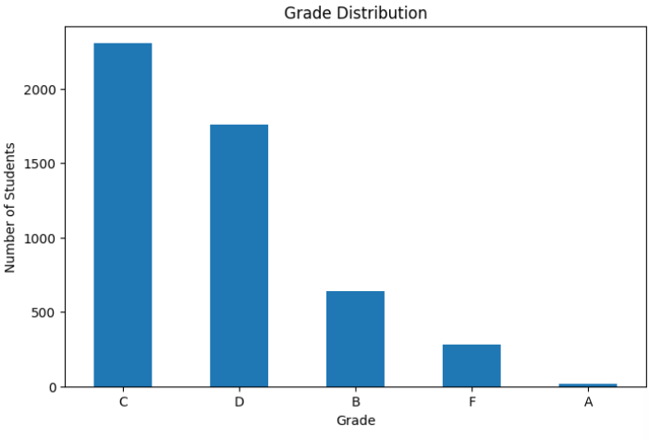

6.2 Grade Distribution Pie Chart
A pie chart is used to represent the proportion of students in different grade categories.
It provides a visual representation of the distribution of grades in the dataset.
Figure 6.2: Grade Distribution Pie Chart
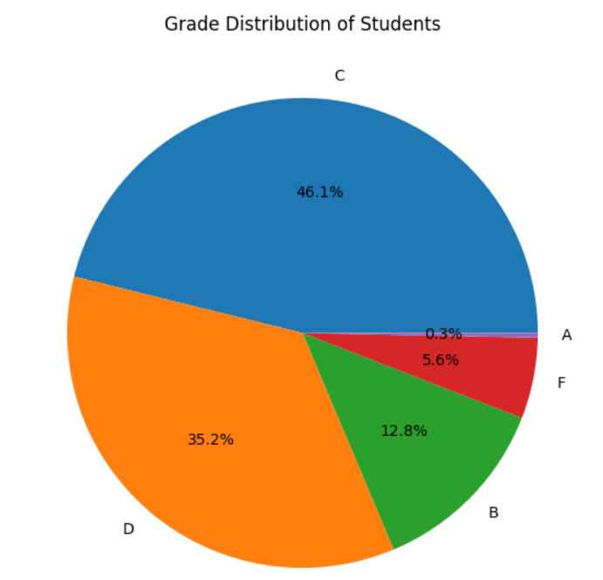

6.3 Box Plot for Outlier Detection
A box plot is used to examine the distribution of numerical data and identify potential outliers.
In this project, the box plot is used as part of the preprocessing stage to check numerical columns such as:
- Age
- Attendance
- Midterm Score
- Final Score
- Total Score
- Average, where applicable
The box plot helps identify values that may be unusually high or low compared with the rest of the data.

6.4 Midterm and Final Performance Comparison
A performance comparison graph is used to compare the Midterm and Final scores of students.
This visualization helps in understanding the difference between students' midterm and final examination performance.
Figure 6.4: Midterm vs Final Performance Comparison
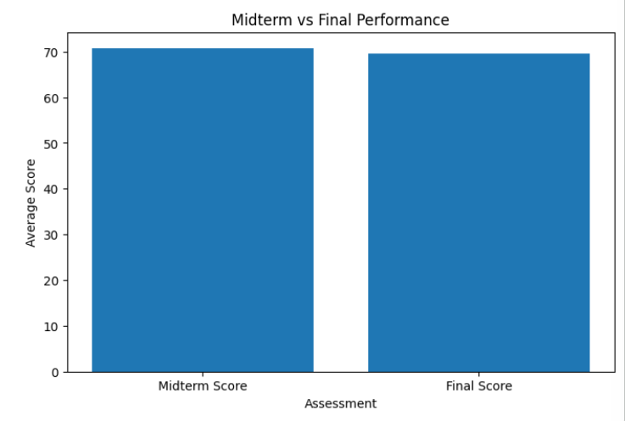

6.5 Department-wise Performance
A department-wise performance graph is used to compare the average performance of students across different departments.
The average score is calculated for each department using the student Average column.
Figure 6.5: Department-wise Average Performance
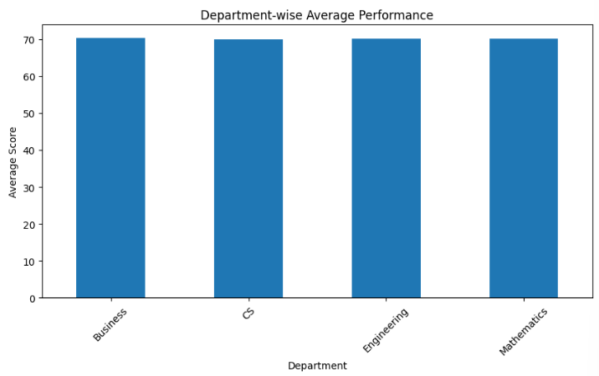

6.6 Top 10 Student Performance
A graph is used to display the performance of the top 10 students based on their calculated average.
Students are sorted in descending order of Average, and the highest-performing students are selected for visualization.
Figure 6.6: Top 10 Student Performance
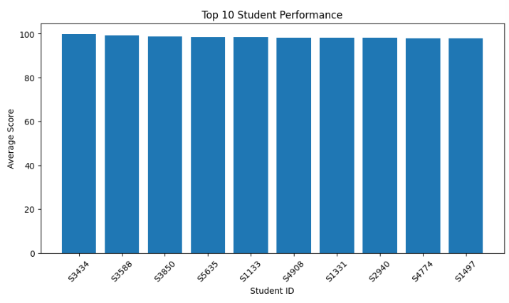

6.7 Student Performance Comparison
The project uses performance comparison visualizations to make the numerical analysis easier to understand.
These visualizations help compare student scores and identify differences in academic performance.

6.8 Interpretation of Visualizations
The visualizations generated in the project help in understanding student academic performance.
The graphs provide information about:
- Distribution of students across grade categories
- Comparison of midterm and final performance
- Department-wise average performance
- Performance of top-performing students
- Differences in student performance
- Possible outliers in numerical data
The visual representations make the results easier to understand and support the analysis of student performance.

CHAPTER 7 — MODEL EVALUATION / ANALYSIS OF RESULTS
Since your project does not use a machine-learning model, this chapter should be treated as:
ANALYSIS OF RESULTS
7.1 Evaluation Metrics
Traditional ML metrics such as:
- Accuracy
- Precision
- Recall
- F1-score
are not applicable because the project does not train a prediction model.
Instead, the following analysis measures are used:
- Number of students
- Overall average
- Highest average
- Lowest average
- Average midterm score
- Average final score
- Grade distribution
- Number of high performers
- Department-wise average

7.2 Experimental Results
After processing the dataset, the system produces:
- Cleaned student dataset
- Average scores
- Grade analysis
- Sorted student records
- Filtered student records
- Topper information
- Department-wise analysis
- Grade distribution
- Performance graphs
- Final analysis report
Important
Put your actual numerical results from your Colab output here.
Don't invent numbers.
For example:
The dataset contains _____ students and _____ columns.
The overall average score is _____.
The highest student average is _____.
Fill these from your actual output.

7.3 Result Interpretation
The analysis allows us to understand student academic performance.
The system identifies high-performing students based on their calculated average.
Grade distribution shows how students are distributed across different performance categories.
Department-wise analysis helps compare the average performance of students across departments.
The visualization results make the numerical findings easier to understand.

7.4 Discussion
The developed system successfully performs the major stages of student performance data analysis.
The system reduces the need for repeated manual calculations and provides structured results.
Data cleaning improves the quality of the dataset before analysis.
Performance analysis provides information about averages, grades, toppers and department-wise performance.

CHAPTER 8 — OUTPUT SCREENSHOTS
This chapter presents the screenshots of the actual outputs obtained during the execution of the Student Performance Data Analysis System in Google Colab. The screenshots demonstrate dataset loading, preprocessing, visualization, and performance analysis results.
8.1 Input / Dataset Screenshots
8.1.1 File Upload
Figure 8.1:
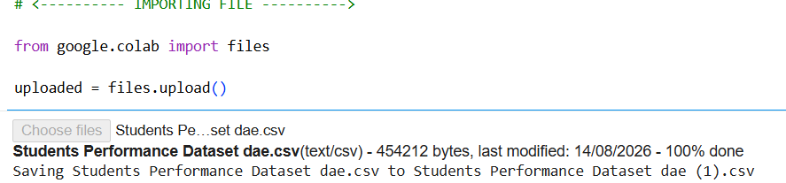

8.1.2 Dataset Loaded Successfully
Figure 8.2
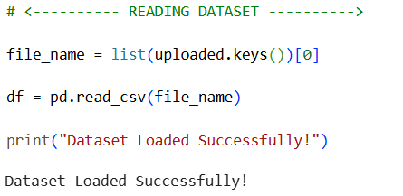

8.1.3 First Five Records
Figure 8.3:
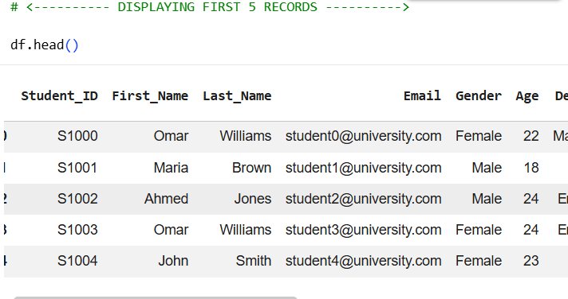

8.1.4 Last Five Records
Figure 8.4:
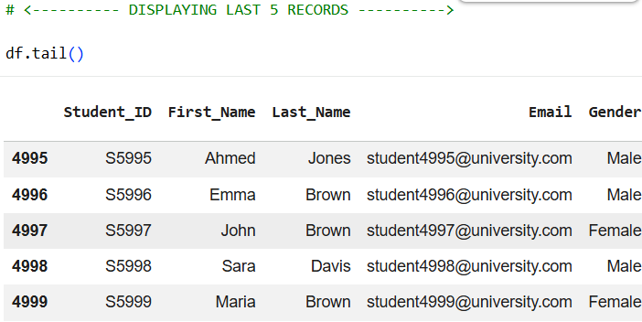

8.1.5 Dataset Size
Figure 8.5:
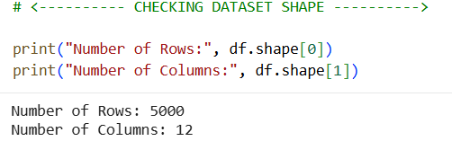

8.2 Preprocessing Outputs
8.2.1 Missing Value Analysis
Figure 8.6:
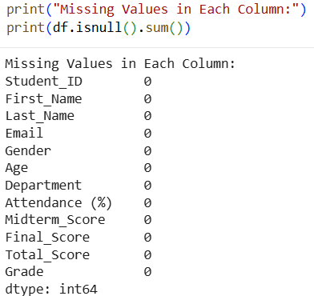

8.2.2 Duplicate Record Analysis
Figure 8.7:
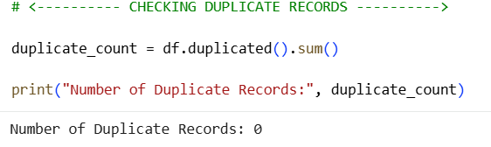
8.2.3 Incorrect Data Checking
Figure 8.8:
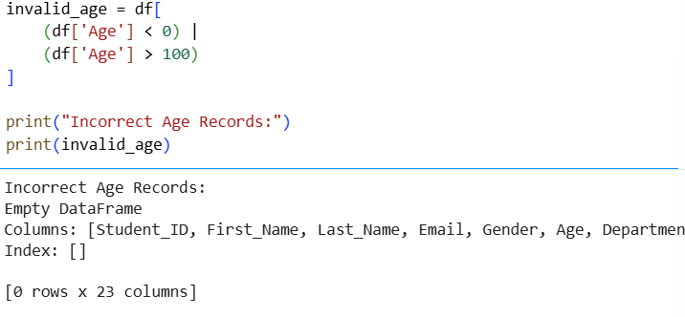

8.2.4 Outlier Detection
Figure 8.9:
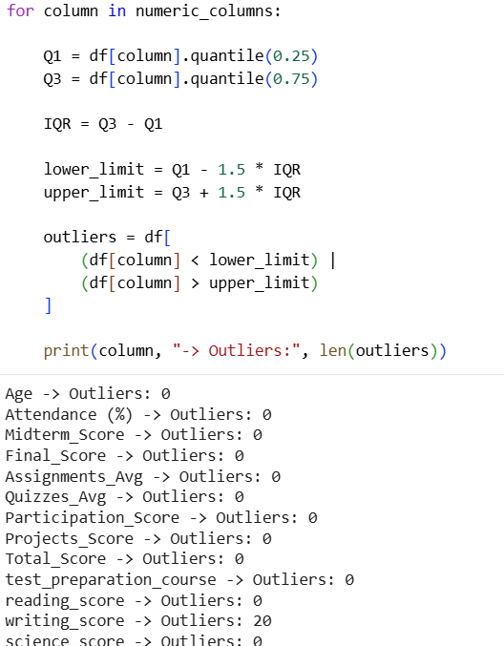

8.2.5 Average Column Creation
Figure 8.10:
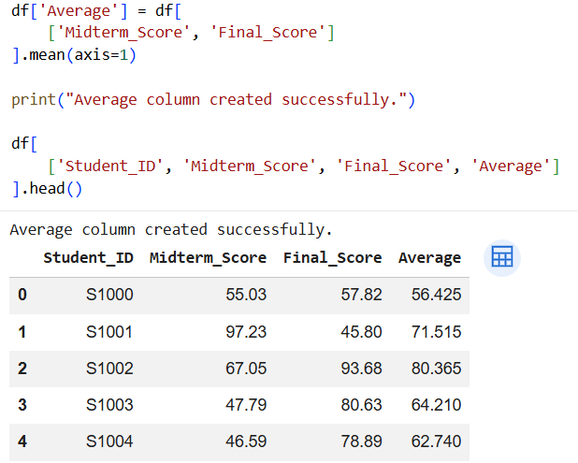

8.2.6 Preprocessing Verification
Figure 8.11:
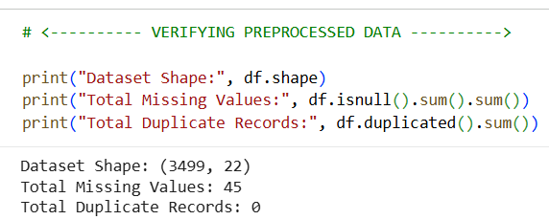
8.3 Visualization Outputs
8.3.1 Grade Distribution Bar Graph
Figure 8.12:
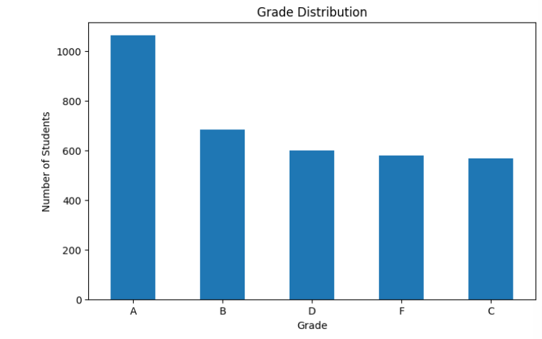

8.3.2 Grade Distribution Pie Chart
Figure 8.13:
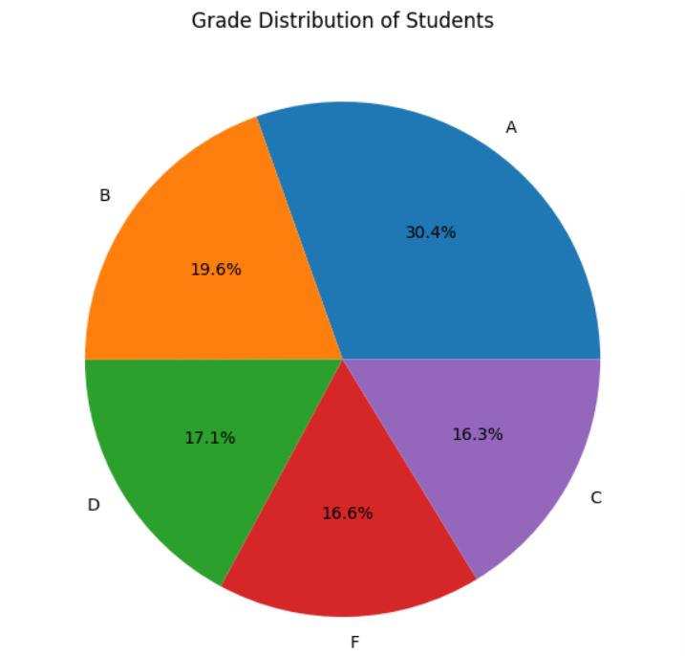

8.3.3 Midterm vs Final Performance
Figure 8.14:
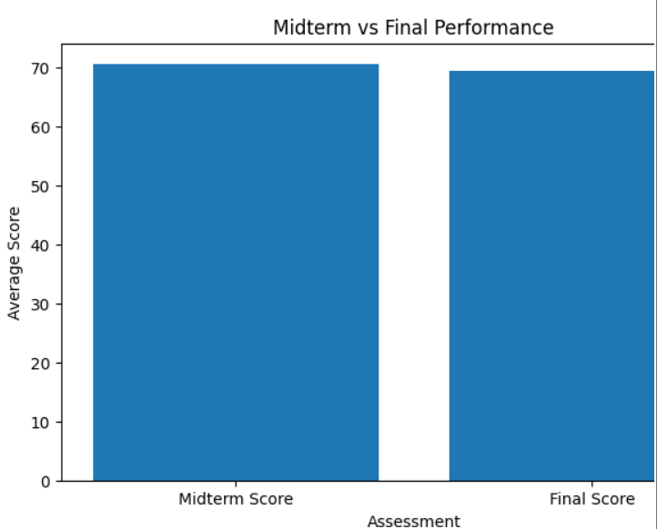

8.3.4 Department-wise Performance
Figure 8.15:
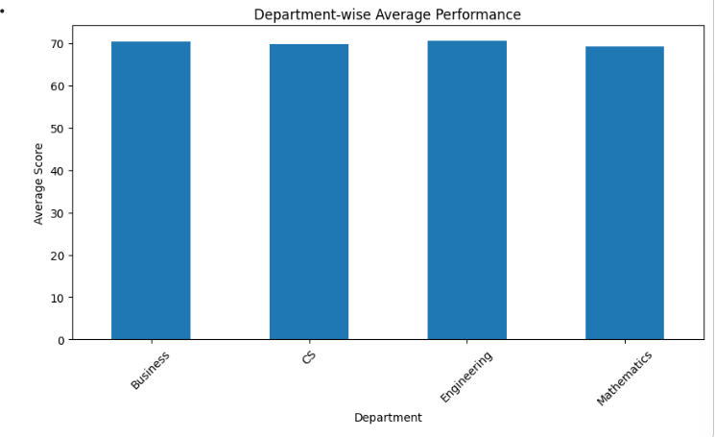
8.3.5 Top 10 Student Performance
Figure 8.16:
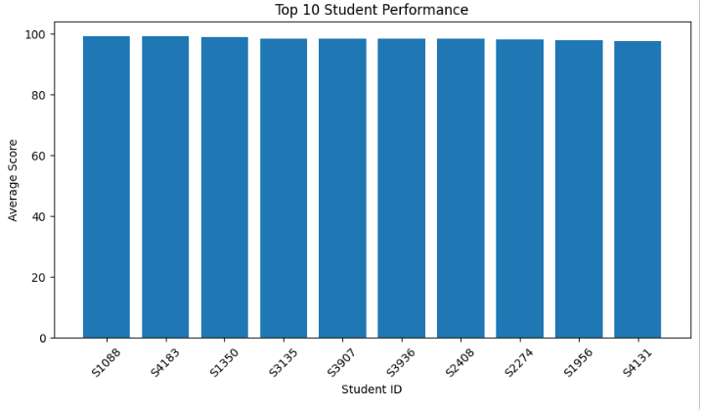

8.4 Performance Analysis Outputs
8.4.1 Topper Identification
Figure 8.17:
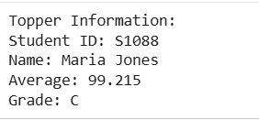

8.4.2 High-Performing Students
Figure 8.18:
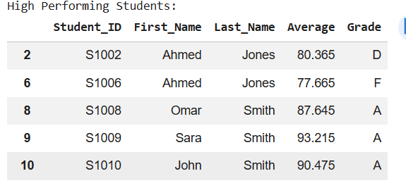

8.4.3 Department-wise Analysis
Figure 8.18:
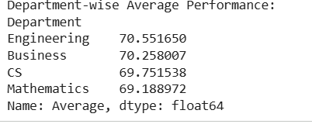

8.4.4 Final Analysis Report
Figure 8.19:
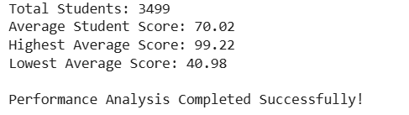

CHAPTER 9 — CONCLUSION AND FUTURE ENHANCEMENTS
9.1 Conclusion
The Student Performance Data Analysis System successfully demonstrates the use of Python-based data analysis techniques for analyzing student academic performance.
The system performs:
- Dataset loading
- Data exploration
- Data cleaning
- Data preprocessing
- Performance analysis
- Sorting and filtering
- Grade analysis
- Topper identification
- Visualization
- Report generation
Pandas is used for data manipulation, NumPy for numerical operations and Matplotlib for visualization.
The project provides meaningful insights into student performance and reduces the effort required for manual analysis.

9.2 Limitations
The current system has some limitations:
- It mainly works with structured CSV data.
- It does not provide a real-time database.
- It does not include an interactive dashboard.
- It does not currently perform machine-learning-based prediction.
- Results depend on the quality and completeness of the input dataset.
- Analysis needs to be rerun when a new dataset is uploaded.

9.3 Future Enhancements
The project can be enhanced by:
- Developing an interactive web dashboard.
- Integrating a database.
- Adding real-time student data.
- Adding advanced statistical analysis.
- Adding machine-learning-based performance prediction.
- Identifying students who may require academic support.
- Adding user authentication for teachers and administrators.
- Providing downloadable PDF/Excel reports.

CHAPTER 10 — REFERENCES
Use only sources that you actually used.
Example:
- Python Documentation
- Pandas Documentation
- NumPy Documentation
- Matplotlib Documentation
- Google Colab Documentation
- Student Performance Dataset source
If you downloaded your test dataset from Kaggle, include the actual Kaggle dataset name and URL in your references.

CHAPTER 11 — APPENDIX – SOURCE CODE
At the end of the record, attach your complete Google Colab code.
Organize it exactly like this:
APPENDIX – SOURCE CODE
<---------- MODULE 1: DATASET LOADING ---------->
tasks: Import libraries, Load dataset, Display records.
<---------- MODULE 2: DATA EXPLORATION ---------->
Data Exploration with: Dataset shape, Column names, Data types, Missing values, and Statistical summary.
<---------- MODULE 3: DATA CLEANING ---------->
Module 3 contains:
- Check missing values
- Check duplicates
- Handle incorrect records
<---------- MODULE 4: DATA PREPROCESSING ---------->
Module 4 includes:
- Remove duplicate records
- Handle missing values
- Check outliers
- Prepare numerical data

<---------- MODULE 5: PERFORMANCE ANALYSIS ---------->

- Student average
- Grades
- Performance
<---------- MODULE 6: VISUALIZATION ---------->
Bar graphs
Piecharts
Comparing
<---------- MODULE 7: REPORT GENERATION ---------->
- Cleaned dataset
- Grade distribution
- Final report

